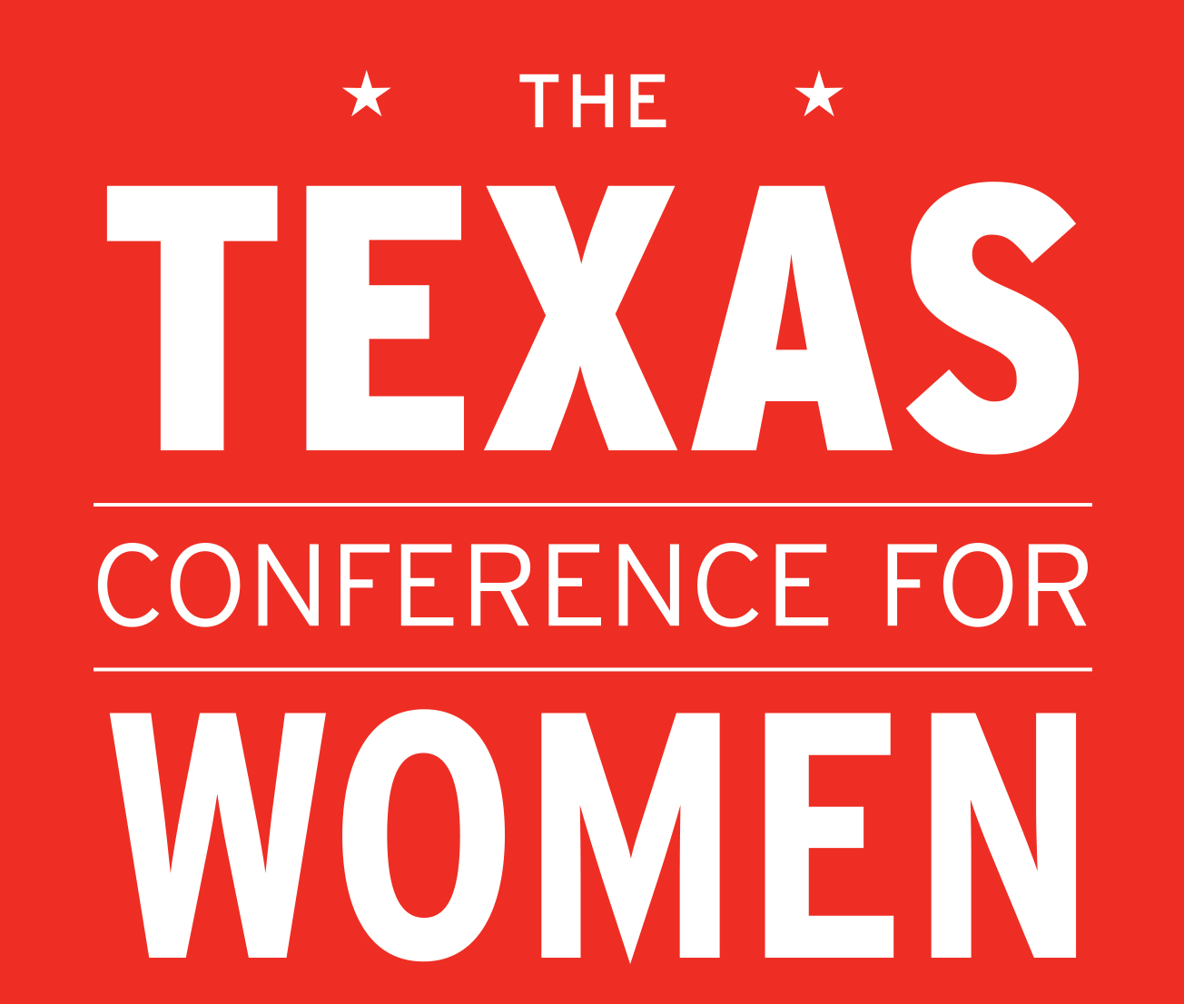
Media Contacts:
Julia Ballantyne
jballantyne@conferenceforwomen.org
916-390-4671

FOR IMMEDIATE RELEASE:
July 24, 2014

Soledad O’Brien, Diana Nyad, Others to Speak at Texas Conference for Women
Austin to Host Thousands for State’s Largest Gathering for Women

Austin, TX - The 2014 Texas Conference for Women announced today that Soledad O’Brien, award-winning journalist, documentarian, news anchor and producer, and Diana Nyad, endurance swimmer and author, will appear as keynote speakers at the 15th annual Texas Conference for Women on November 13, 2014 at the Austin Convention Center. At CNN, O’Brien created the “Black in America” and “Latino in America” documentary franchises, redefining in-depth story-telling. Today she is CEO of Starfish Media Group where she continues producing segments that focus on empowering, personal stories that challenge the issues of race, class, wealth, poverty and opportunity. Nyad last year became the first person to complete the 103-mile swim from Cuba to Florida without a shark cage. She did so on her 5th attempt at the age of 64. O’Brien and Nyad are joined by Shiza Shahid, CEO and co-founder of the Malala Fund, Sheryl WuDunn, Pulitzer-Prize winner and New York Times best-selling co-author of Half the Sky, and Debbie Sterling, the founder and CEO of GoldieBlox.

“We are thrilled to celebrate our 15th anniversary by hosting women of such courage, creativity and vitality,” said Texas First Lady Anita Perry, host of the Texas Conference for Women. “Soledad O’Brien, Diana Nyad and our other speakers will inspire women to aim high and reimagine the impact they can have in their own lives and in their communities.”

Other speakers include Louis van Amstel, champion ballroom dancer and Dancing with the Stars instructor; Jenny Bowen, founder and CEO of Half the Sky; Jane Hyun, leadership strategist and author of Breaking the Bamboo Ceiling: The Essential Guide to Getting In, Moving Up, and Reaching the Top; Tara Sophia Mohr, creator and founder of Playing Big; Danielle Laporte, author of The Desire Map and The Fire Starter Sessions; Ritu Sharma, co-founder and president of Women Thrive Worldwide; Gail Sheehy, New York Times best-selling author of Passages; Kate White, former editor in chief of Cosmopolitan and New York Times best-selling author of If Looks Could Kill and Hush and Joan Williams, author of What Works for Women at Work. These speakers are among the 100+ to be featured at this year’s Conference.

“There is no better way to celebrate our 15th anniversary Conference than hearing from this diverse and strong-spirited group of leaders,” said Johnita Jones, President of the Board of the Texas Conference for Women. “Our attendees will gain valuable paths to success in career and in life, and new insights into finding happiness and balance in their busy lives.”

The 15th annual Conference hosts thousands of women from across the state for a full day of networking, inspiration, professional development and personal growth. The one-day Conference features keynote addresses, and breakout sessions led by more than one hundred experts in the fields of business, philanthropy, health, finance, media and professional development. The nonprofit, nonpartisan event draws women of all ages and backgrounds who are interested in building communication skills, leadership strategies and work-life balance tools.

The Texas Conference for Women is generously underwritten by AT&T, AAA Texas, Austin American-Statesman, AW Media, Cancer Treatment Centers of America, Cisco, Clear Channel Outdoor, Dell, Freescale, Hail Merry, HEB, Pfizer, Phillips 66, Rackspace, Shell, The Texas Tribune, USAA and United Airlines.
Registration is now open and early bird pricing is valid through August 15, 2014. To register or learn more about the 15th annual Texas Conference for Women, visit our website at www.TXConferenceforWomen.org. To apply for media credentials, please contact Julia Ballantyne, jballantyne@conferenceforwomen.org.

Follow us on @TexasWomen Like us on TexasConferenceforWomen
###

