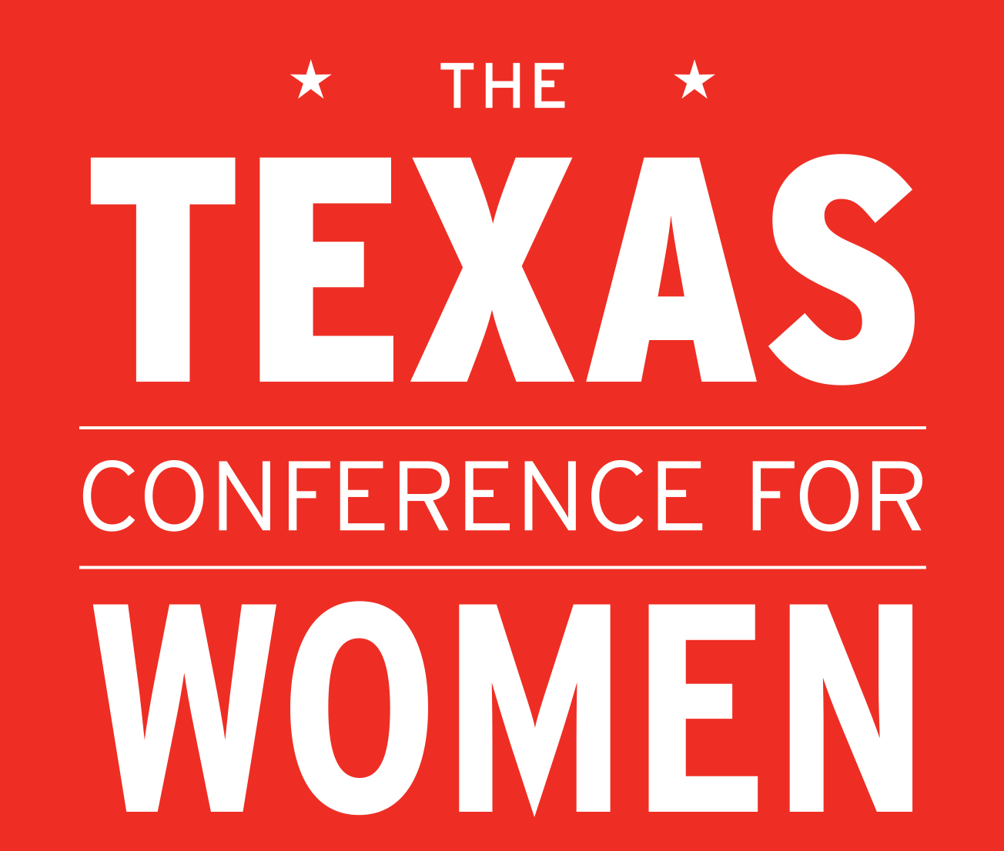

Media Contacts:
Julia Ballantyne
jballantyne@conferenceforwomen.org
916-390-4671

FOR IMMEDIATE RELEASE:
November 13, 2014

Diana Nyad, Soledad O’Brien, Others Inspire Audience at Texas Conference for Women
Austin Hosts Thousands for State’s Largest Gathering for Women

Austin, TX – “When you are chasing your dreams you’re not doing it as a woman,” world famous endurance swimmer Diana Nyad told attendees at the 15th Annual Texas for Women at the Austin Convention Center. “You’re a citizen of the world who deserves to lead a meaningful, happy life.” Last year, Nyad became the first person to complete the 110-mile swim from Cuba to Florida without a shark cage. She did so on her 5th attempt at the age of 64. “You are forgetting the most critical element here,” Nyad said she told her skeptics. “That's the power of the human spirit."

The Texas Conference for Women is the state’s largest personal and professional development event for women, attracting 6000 attendees this year. The audience also heard from Soledad O’Brien, award-winning journalist, documentarian, news anchor and producer. “Making a risky career decision is not about your career,” O’Brien said of her own professional transitions. “It is always about the kind of life you want to lead and the kind of impact you want to have.” Other keynoters included Tamara Mellon, the former chief executive officer and chief creative officer of Jimmy Choo and founder of TAMARA MELLON brand and Sheryl WuDunn, Pulitzer-Prize winner and New York Times best-selling co-author of A Path Appears and Half the Sky. The Conference also featured Malala Fund CEO and co-founder Shiza Shahid, and Debbie Sterling, the founder and CEO of GoldieBlox, an award-winning toy company that encourages girls to pursue engineering and technology from a young age.

Attendees at today’s 15th Anniversary event heard from over one hundred speakers discussing issues that matter most to women’s lives, participated in skill-building sessions with industry experts and developed new relationships with women from across the state.

“We could not be more excited to have such remarkable speakers with us today as we celebrate this special 15th anniversary of the Texas Conference for Women,” said Texas First Lady Anita Perry, co-founder and host of the Conference. “We set out to create a day that will inspire, educate and empower women, and I know all of our attendees will leave here today with the confidence and motivation they need to overcome any obstacle and to blaze new trails.”

A Conference favorite, Local Leader meet-ups offered attendees the chance to have one-on-one conversations with local businesswomen and community leaders, and intimate Coaches Corner sessions gave attendees an opportunity for one-on-one “speed coaching” with a coach from International Coach Federation (ICF) Austin or from Texas Women in Business (TWIB). Conference attendees also had the opportunity to experience the new Cisco Networking Lounge as well as participate in the Career Pavilion, featuring resume reviews by human resource experts.

Additionally, the Conference Health & Wellness Pavilion featured exciting speakers throughout the day discussing important health topics, and attendees had the chance to visit onsite exhibits featuring hundreds of organizations and companies offering a variety of services and products that specifically appeal to women.

“We are honored to support and encourage the thousands of women gathered today in Austin for this transformative event,” said Gayle Morris, Vice President, Americas Services at Cisco Systems. “For 15 years now, the Conference has empowered and motivated women to pursue new goals in their personal and professional lives. We’re thrilled to be a part of this extraordinary anniversary and proud to be the Exclusive Networking Sponsor of the Conference.”

The Texas Conference for Women is generously underwritten by Cisco, Dell, Freescale, Hail Merry, Rackspace, United, AT&T, Phillips 66, Shell, Cancer Treatment Centers Of America, HEB, Pfizer, Texas Beverage Association, AAA Texas, CVS Caremark, ExxonMobil, Home Away, Hewlett-Packard, Intel, Morgan Stanley, NRG, Raytheon, TidBits Media Group, Time Warner Cable, USAA, Walgreens, Austin American-Statesman, Austin Monthly, AW Media, Clear Channel Media and Entertainment, Clear Channel Outdoor, KXAN and The Texas Tribune.

To learn more about the 15th annual Texas Conference for Women, visit our website at www.TXconferenceforwomen.org, follow us on Twitter @TexasWomen, or visit our Facebook page at @TexasConferenceForWomen. Photos of the event may be obtained from www.gettyimages.com.

# # #

