Dear [MANAGER’S NAME],
I’m writing to request your approval to attend the Texas Conference for Women on November 16, 2023 at the Austin Convention Center. The Conference covers a range of topics relevant to professional and personal development for women in the workplace — including building community for hybrid and remote teams, effective and inclusive communication, and leadership strategies for the new world of work.
This Conference is part of the largest network of women’s professional conferences in the nation. The cost to attend is $299 for an individual, or $2,990 for a table of ten. More information, including this year’s complete program agenda, is available at txconferenceforwomen.org.
Former New Zealand Prime Minister Jacinda Ardern, known for ushering in a new era of strong, empathetic leadership, will be one of the keynote speakers.
Elizabeth Banks will also speak. From indie films to blockbusters to record-setting directorial debuts, Banks is uniquely qualified to talk about making bold moves in a male-dominated field. At the Conference, she will help all of us to refine our perspectives on allyship, self-advocacy, and more in the workplace.
Also appearing is Gail Devers, a five-time Olympian, nine-time World Champion and three-time Olympic gold medalist in track and field who was one of the fastest women alive for almost two decades. But before she first won gold, she suffered for years from mysterious health symptoms. She will share her journey from medical despair to the U.S. Olympic Hall of Fame, and lessons she learned along the way around persistence and grit that all of us can apply to any challenges that we are facing.
These are just a few of dozens of speakers who will share their stories, insights, and practical, actionable advice. They will join a luminous roster of past Conference speakers, including Brené Brown, Mallika Chopra, Amal Clooney, Viola Davis, Adam Grant, Melinda French Gates, Doris Kearns Goodwin, Indra Nooyi, Sheryl Sandberg, Diane von Furstenberg, Reese Witherspoon, Malala Yousafzai, and many others.
The Conference will also provide a unique opportunity for connection – not only with my peers, but with thousands of professional women and allies in attendance. Past year’s attendees have reported that they felt better able to meet the professional challenges of the moment because they attended. I am eager to grow from the helpful tips and resources that the Conference will provide, and to bring these learnings back to our workplace to strengthen our team.
Thank you for taking the time to review this request.
Sincerely,
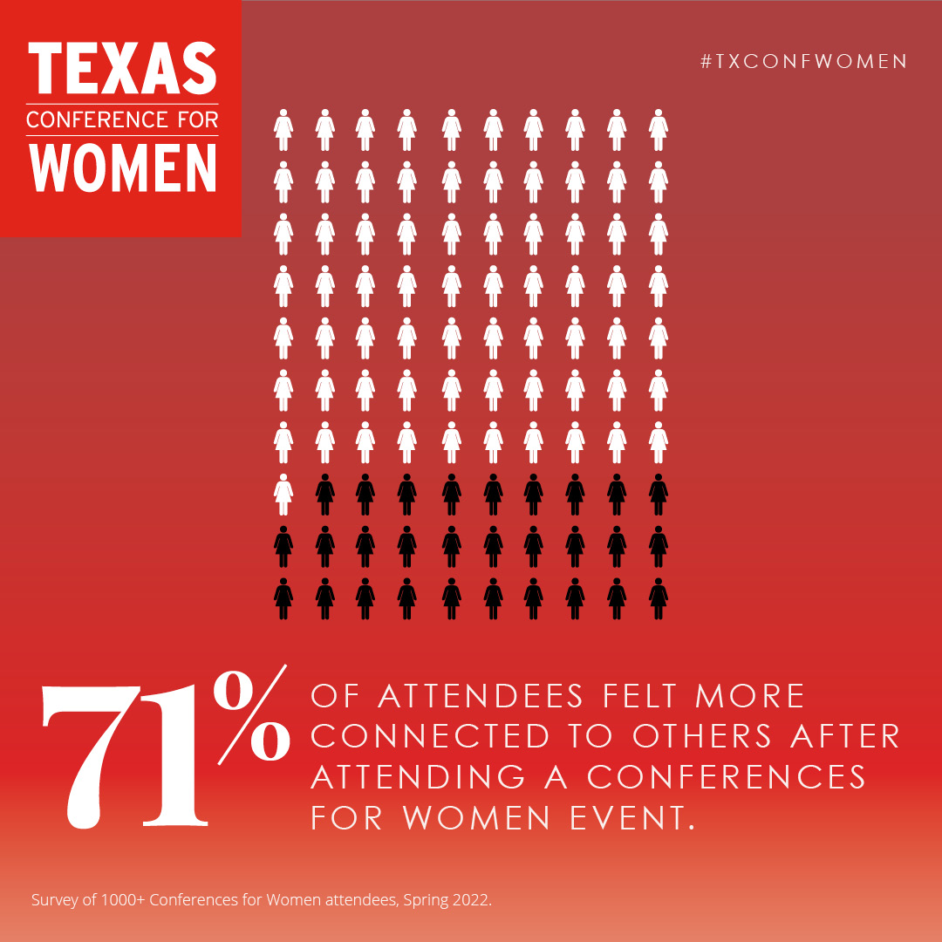
[YOUR NAME]
